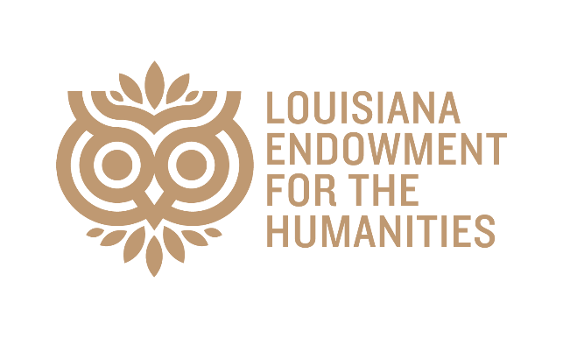
STRATEGIC PARTNERSHIP GRANTS
LEH awards Strategic Partnership grants to organizations producing high-impact humanities programming. These organizations represent longtime, trusted partners in geographically diverse areas of the state.
With the support of the State of Louisiana, the LEH has awarded $47,500 in Strategic Partnership Grants to ten nonprofit cultural organizations across eight parishes.

Banners at McNeese State University
Banners Cultural Season 2026
Lake Charles, LA
Calcasieu Parish
$9,000
Claiborne Unite Foundation
LA Legends Fest
Homer, LA
Claiborne Parish
$5,000
Festival of Words Cultural Arts Collective
“Hurricanes Katrina and Rita at 20: Poets Remember”
Lafayette, LA
Lafayette Parish
$1,000
Festivals Acadiens et Creoles, Inc.
Scene Atelier at Festival Acadiens et Creoles
Lafayette, LA
Lafayette Parish
$5,000
HARK
HARK Festival 2026
Rodessa, LA
Caddo Parish
$5,000
Iberia Cultural Resource Association
10th Annual Books Along the Teche Literary Festival
New Iberia, LA
Iberia Parish
$2,500
Louisiana Library Foundation
Louisiana Book Festival
Baton Rouge, LA
East Baton Rouge Parish
$10,000
New Orleans Book Festival at Tulane University
2026 New Orleans Book Festival at Tulane University
New Orleans, LA
Orleans Parish
$5,000
The Louisiana Music and Heritage Experience, Inc.
NOLA Funk Fest
New Orleans, LA
Orleans Parish
$2,500
Whitney Plantation
Whitney Plantation Juneteenth Event 2026
Wallace, LA
St. John the Baptist Parish
$2,500

