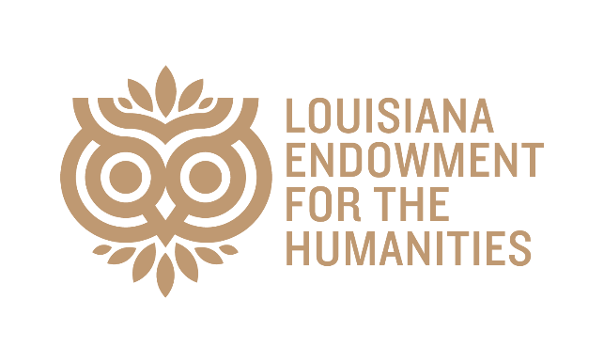
2026 PROGRAM MINI GRANTS
Program Mini Grants provide support for small-scale projects that engage local audiences with Louisiana scholars to explore the history, foodways, folkways, music, and culture that make Louisiana’s towns, parishes, and state so unique.
The Louisiana Endowment for the Humanities, with the support of the State of Louisiana, has awarded $8,000 in Program Mini grants to nine nonprofit cultural organizations across six parishes.

Concordia Parish Library
History of Louisiana Juke Joints and Dance Halls
Ferriday, LA
Concordia Parish
$500
Gulf Coast Asian Arts & Culture
Crafting Heritage: A Public Conversation on Vietnamese arts in Louisiana
Harvey, LA
Jefferson Parish
$1,000
Institute for Public Ethnomusicology
Mozambique: ritmo carnavalesco en Nueva Orleans / Carnival Rhythm in New Orleans
New Orleans, LA
Orleans Parish
$500
Mid City Civic Theatre
Stage & Screen in Louisiana: Past, Present, and Future
Baton Rouge, LA
East Baton Rouge Parish
$1,000
New Orleans Poetry Festival, Inc.
New Orleans Poetry Festival, 2026
New Orleans, LA
Orleans Parish
$1,000
Nous Foundation
One Single Place: History Symposium
New Orleans, LA
Orleans Parish
$1,000
Shadows-on-the-Teche
Faith and Freedom Symposium
New Iberia, LA
Iberia Parish
$1,000
South Louisiana Wetlands Discovery Center
LouisianaLIT at the Bayou Terrebonne Waterlife Museum
Houma, LA
Terrebonne Parish
$1,000
United Houma Nation, Inc.
United Houma Nation Powwow
Houma, LA
Terrebonne Parish
$1,000

