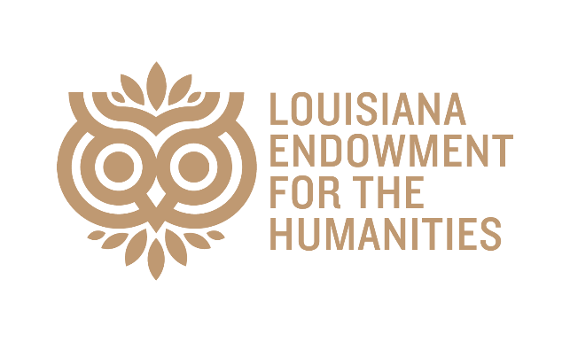
LOUISIANA CULTURE CARE FUND RECIPIENTS
With support from the State of Louisiana, the Louisiana Endowment for the Humanities (LEH) has awarded $100,000 in grants to 13 humanities organizations in 10 parishes to help with operational expenses.

Gulf Coast Asian Arts & Culture
Harvey, LA
Jefferson Parish
$5,000
Herbert S. Ford Memorial Museum. Inc.
Homer, LA
Claiborne Parish
$5,000
Union Museum of History & Art
Farmville, LA
Union Parish
$5,000
Acadian Heritage and Culture Foundation
Erath, LA
Vermilion Parish
$5,000
Freedom to Grow
New Orleans, LA
Orleans Parish
$5,000
The Pirate's Alley Faulkner Society, Inc.
New Orleans, LA
Orleans Parish
$5,000
University of Louisiana at Lafayette, Center for Louisiana Studies
Lafayette, LA
Lafayette Parish
$5,000
Iberia African American Historical Society
New Iberia, LA
Iberia Parish
$10,000
Grant Parish Library
Colfax, LA
Grant Parish
$10,000
LA Prison Museum and Cultural Center
Angola, LA
West Feliciana Parish
$10,000
Amistad Research Center
New Orleans, LA
Orleans Parish
$10,000
NUNU Arts and Culture Collective
Arnaudville, LA
St. Martin Parish
$10,000
New Orleans African American Museum
New Orleans, LA
Orleans Parish
$15,000

